

*Data Validation:*

*Production*

**Table of Contents**

Data Validation 3

Why 3

Roles & Responsibilities 3

Import Key Setup 4

Units of Measure 4

Items 5

Why 5

What to check 5

How 7

Roles & Responsibilities 7

Formulas 8

Why 8

What to check 8

How 10

Roles & Responsibilities 10

Inventory 11

Why 11

What to check 11

How 15

Roles & Responsibilities 15

Data Validation – Full Circle 16

Data Imported 16

Data Validated 16

Data Processed 16

Postings 16

Reports 16

Why Data Validation Is Critical 17

Lower Risks 17

Go Live Duration 17

Customer Service 17

Procurement 17

Reporting 17

Success 17

# Data Validation

## Why

Why is data validation critical to any ERP implementation? Data is one of the most important parts of any implementation. The old saying of “Garbage In / Garbage Out” can be applied here. If we load bad or poor-quality data, the outputs of that data will be bad or have poor-quality. The more data validation that is done during implementation, the better the overall outputs will be. Taking ownership of the data begins with data validation. It will also provide a smoother transition and reduce or eliminate issues at Go Live. Data and data validation are key to a successful Go Live.

## Roles & Responsibilities

There are several roles that are involved with data validation. It’s a team effort. The Data Specialists, the Product Specialists, Subject Matter Experts (SMEs) and End Users have critical roles to play in data validation.

The Data Specialist’s role in validation is the same for every section so we will discuss here. It begins with the load file. Along with the Product Specialist (PS), they will review the file and determine where the data will reside in DEACOM. The Data Specialist’s responsibility is to confirm record counts and validate the information in the file loaded to the fields mapped in the data profile. This is the first level of data validation. The data profile will be modified to fix any issues found during this validation. However, the file may be missing key information that the data specialist does not know exists or during implementation new data is identified that is required to support a new process.

Data Specialists can also provide spreadsheets that can be used to easily filter or sort and review many records at one time. **Note: these spreadsheets are for validation only and will not be used to update every field on the spreadsheet. However, the spreadsheets can be used to update a single field.** The root cause of any data issue will be researched, and the data profiles updated so the data can be updated, and new records will come in with the proper changes and existing records will be updated.

The Product Specialist’s role in validation is to review the data loaded for every section and help discover, during Standard Operating Procedures (SOPs) validation, if we are missing any key data, while at the same time validating these processes using the imported data. This data will also be used in Mock Go Live and Conference Room Pilots (CRPs).

# Import Key Setup

## Units of Measure

DEACOM has a centralized unit of measure (UOM) functionality. The advantage of this setup is that the conversion factor can be setup once instead of multiple times. The setup of the unit of measure conversion factors affects Items, Purchase Orders, Sales Orders, Formulas, and Jobs, so it is crucial that it is setup correctly. It is important to discuss and validate the UOM table early in the implementation. Why? Because it affects all areas of the system including imported Sales Order, Purchase Order and Inventory data. A change in the UOM table can cause incorrect reporting to happen.

For example, an imported invoice has a qty of 1 Drum with a sales unit of Each. The drum holds 55 gallons. The item stock unit at the time of import was Each. This invoice would show 1 Drum was taken out of inventory. If the stock UOM is changed to Gallons after the import, the invoice thinks it took 1 gallon out of inventory when it should show 55 gallons. Reporting would be incorrect.

# Items

## Why

Item Master records are another key data element for a successful Go Live. The combination of flags on the Properties tab determine how Parts may be used throughout the system. This includes defining if they may be sold, purchased, taxable, usable in Direct Store Delivery, finished to WIP, serialized, included in MRP, etc. The setup of these items drives how the system functions. The items also affect the general ledger based on how the accounts are setup. If the accounts are wrong, this could potentially make the postings wrong in sales orders, purchase orders, production, etc. The UOM setup is critical to how inventory is stored and recorded on purchase and sales orders.

## What to check

The best place to start checking is the basic information. For example, Item/Part Number, Category, Item Planner, UOMs, Item Type, Accounts, Costs and the Properties flags are the essential fields. Shelf life, Min, Max, UPC codes, Part forms, search field and UDFs should also be reviewed. Templates are used to set the majority of properties, so it is important to validate those templates.

Where to begin?

* Highest volume supplies.
* Highest volume raw materials.
* Highest volume components.
* Highest volume sub-assemblies.
* Highest volume finished goods.
* If using MRO, check maintenance parts and maintenance task items.
* If you are bringing in inactive items for historical formulas or orders, check a few of those too.
* In DEACOM, go to **Inventory > Item Master**
* **Report Type**: Standard
  + **Display**: All (shows both active and inactive)
  + Click on **View**

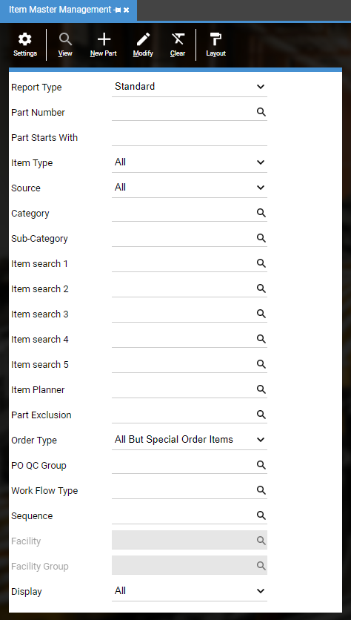

* To see your legacy Part Number, add pr_retail to the grid

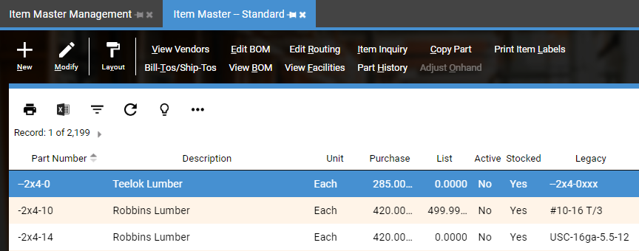

* Compare to items from legacy system

**General tab**

Validate Item Type

**General 2 tab**

Validate Shelf life days

**MRP tab**

Validate MRP Mins/Maxs if used

**Properties tab**

Validate Properties

**User Fields tab**

Validate Search Fields

**Units tab**

Validate Units of Measure (If you find widespread problems, notify your Project Manager and Data Specialist.)

**QC / Stability Tests tab**

Validate QC / Stability Tests

**Costs tab**

Validate Current materials, Acct. materials (standard) costs

**Accounts tab**

Validate Revenue, Inventory and Adjustment Accounts

Validate Other Accounts as needed

**Other**

Confirm total number of items match the expected number

Validate other key fields

**View Vendors** (Vendor Part Cross References)

Validate Vendor, Part Number, Description, Pricing and any other populated fields

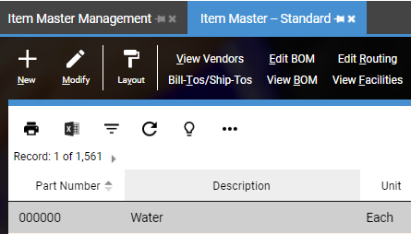

**Bill-Tos/Ship-Tos** (Customer Part Cross References)

Validate Bill-To Company, Customer Part Number, Description, Sales Price, Units of Measure and any other populated fields



## How

The best way is to bring the item up in the legacy system and bring the item up in DEACOM. Carefully compare the data for each field. Be extra careful to review the accounts and costs. If you find information is missing or in the wrong field, contact the data specialist and they will determine why this is happening. Use the spreadsheets discussed previously to view many items at the same time. Filtering in Excel can be useful to quickly see items that are in the wrong category or inventory account.

## Roles & Responsibilities

Typically, Subject Matter Experts, Customer Service, Purchasing, Production and Accounting have the responsibility to validate their portion of the data. They use the data every day and can easily spot if key data is missing. The Accounting group would validate the account information while Production validates the MRP data (min, max, etc), and Purchasing validates PO ordering fields (PO Qty, Min. Purchasable, Incremental PO Qty, Lead times, etc.)

# Formulas

## Why

Formulas or Bill of Materials (BOMs) are the list of the parts or components and quantities of each needed to produce a sub-assembly, finished good or perform a maintenance job. The parts required may include raw materials, components, sub-assemblies, and/or finished goods. BOMs are hierarchical in nature with the top level representing the finished product which may be a sub-assembly or a completed item. In DEACOM, the Bill of Materials also contains information regarding costs and, if setup, the labor costs necessary to produce the item. It is critical that all formulas are validated before use. If the formula is wrong, it could be very costly as too little or too much material may be used, and the end-result is not a useable product, resulting in large inventory expenses, or hazardous chemical reactions. Incorrect costs could affect the GL if in Standard Cost inventory mode and Standards were updated from incorrectly costed formulas.

## What to check

The best place to start checking is the basic information. Confirm what item is being produced, the formula UOM, formula notes, the batch yield and unit cost. At the line level, confirm items, quantities and UOMs. If the formula has QC or Routings, check that the correct one is attached to the formula. Be sure to check if byproducts and/or scrap settings are needed.

Where to begin?

* Highest volume sub-assemblies.
* Highest volume finished goods.
* If using MRO, maintenance formulas.
* In DEACOM, go to **Inventory > Bills of Material**
* **Report Type**: Standard
* Click on **View**

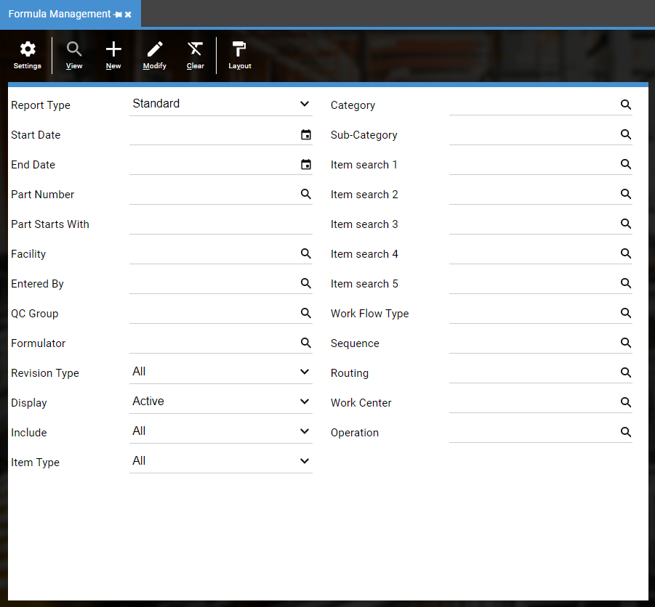

* Compare to formulas from legacy system

**General tab**

Validate Formula unit

Validate Batch yield

Validate Unit cost

**QC / Stability Tests tab**

Validate QC / Stability Tests

**Other**

Validate items, quantities, units of measure

Confirm total number of formulas match expected number

Validate other key fields

## How

The best way is to bring up the formula in the legacy system and bring up the formula in DEACOM. Compare all key fields to determine the formula was imported correctly. Deacom suggests using one of the two setups below:

**Lab Only** is a check box that prevents a formula from being used in Production until the formula is validated and the lab only box is cleared.

**Workflows** can be setup for each area of the formula that needs to be reviewed. The workflow can be setup such that the formula cannot be used in Production until the workflow is completed. This method is the most complete method as many people need to validate the formula and can be working simultaneously to validate.

## Roles & Responsibilities

Typically, Subject Matter Experts, Chemists, Production and Accounting have the responsibility to validate their portion of the data. They use the data every day and can easily spot if key data is missing. The Chemists confirm the formula has the proper ingredients and is making the correct amount. The Accounting group would validate the cost information while Production validates the notes and batch ticket instructions.

# Inventory

## Why

When inventory is loaded into DEACOM, it is loaded in the DEACOM Stock Unit of Measure. It is critical to the Go Live that the costs and quantities are correct for the Stock UOM. If during process engineering, it is determined that the inventory UOM should change, the load files must match the system setup. For example, an item in the legacy system is stored by the bottle but now it will be stored by Case-10. The load file has 1000 when it should have 100 since the system knows 10 bottles are in each Case-10. The overall dollar amount might be correct, but the quantity is incorrect. The system will think it has 1000 Case-10 or 10,000 bottles. Any changes to UOM after Go Live must be done manually due to general ledger effects and the number of tables involved.

## What to check

The best place to start is checking the basic information. Confirm that the item number, quantity in Stock UOM, lot costs, extension, location and facility are correct. Be sure to check lot numbers and expiration dates if applicable. Often overlooked, confirm the correct inventory account is assigned.

Where to begin?

* Highest volume inventory items.
* Items whose Stock UOM changed from the legacy system.
* Items that should have expiration dates.
* Items that should be in quarantine and/or items issued to jobs.
* In DEACOM, go to **Inventory > Inventory Reporting**
* **Report Type**: Lots
* **View, QC Status, ABC, Item type =** All
* **End Date =** date inventory was pulled
* Click on **View**

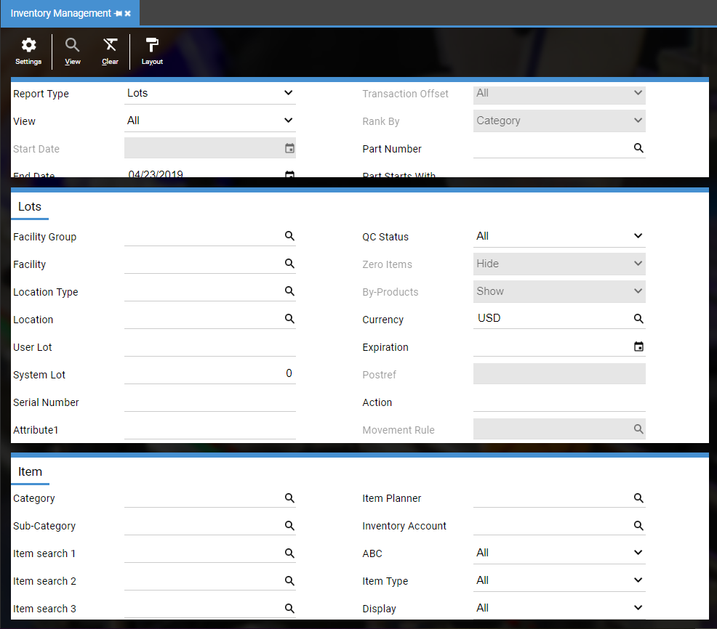

* Compare to Inventory report from legacy system

Confirm total record count

Confirm lot numbers, quantity, lot cost, value, expiration dates

Confirm and record Value (found in the report title bar)

* Use Subtotal button to summarize by inventory account
  + Click On **More (…)**
  + Click on **Subtotals**
  + Click on **Add**
  + Select **Account** (If Account is not an option, add it to the grid)
  + Click on **Save,** thenclose the dialog box
  + Click on **Summary**

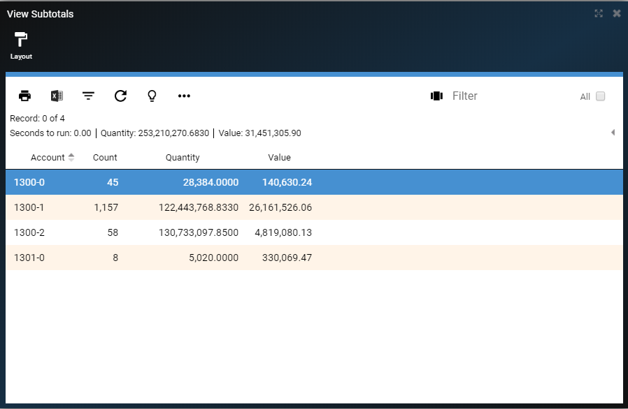

* + This summary should match what is in the G/L (see below)

Confirm inventory in the correct General Ledger Account

* Prior to Actual Go Live, test daily processes using imported data. This typically occurs after a Mock Go Live and/or during a Conference Room Pilot (CRP).

Process Jobs using imported inventory

Total Value above should match the following report:

* In DEACOM, go to **Accounting > Accounting Reporting**
* **Report Type**: Trial Balance
* **Date Range**: First Day of Current Fiscal Year to Go Live Date
* If applicable, run reports by facility, using the Account mask
  + (e.g. ??????-01-??-?? where the second segment is the facility.)

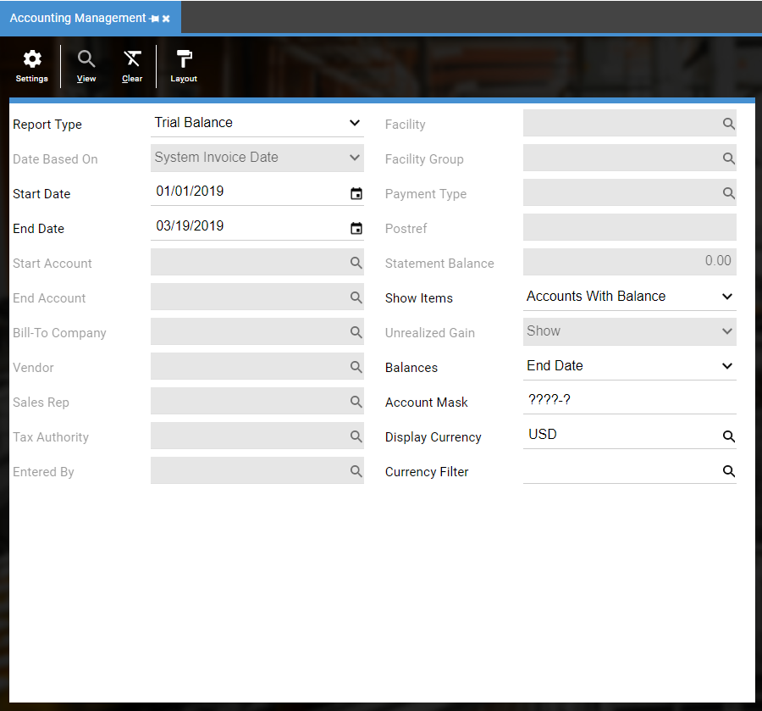

* Click on **View** and filter by Title or Account Range to look at Inventory Accounts
* Click on **Refresh** button to refresh the Debits and Credits on the ribbon bar

Confirm that total Inventory Account balances match the total values above

## How

Start with a Lots report from legacy system and compare to a lots report from DEACOM. In DEACOM, run a Lots report with all filter criteria set to All. Confirm the key fields are correct. Run Lots report by facility to confirm the inventory was loaded to the proper facility. Subtotal report by Account and confirm the proper items are in the proper inventory account. This will affect where the dollars are allocated in the general ledger.

## Roles & Responsibilities

Typically, Subject Matter Experts, Production, Warehouse Managers, and Accounting have the responsibility to validate their portion of the data. The inventory value must tie to the general ledger so Accounting will want to confirm the inventory is in the correct accounts in the general ledger and confirm the value. If GL accounts have a facility segment, each facility’s Warehouse Manager can confirm inventory is in the correct location.

# Data Validation – Full Circle

Below is the full circle for validation.

## Data Imported

Data is imported and validated by the Data Specialists and/or Product Specialist. This validation is a comparison to the load files provided and to confirm the data is going into the correct fields.

## Data Validated

Once imported, it is important for data to be validated by the Subject Matter Experts and/or End Users. This validation is a comparison to the legacy system. Data specialists do not know what is missing if the file never contained the information.

## Data Processed

Once the data is validated, it is time to use the imported data by doing transactions in DEACOM. This ensures the imported data will transact properly with customer specific data. This builds the End Users’ confidence and confidence in DEACOM is higher.

## Postings

Once the data is used in transactions, it is imperative that the general ledger postings are reviewed. That will ensure the configuration of the items, customers, and facilities are posting the dollars to the correct accounts.

## Reports

Once all of the above is completed, run the reports needed to run your business. Are the proper results being captured? All necessary reports should be created and validated before Go Live.

# Why Data Validation Is Critical

When the data has been validated…

## Lower Risks

It has been proven to reduce the risks at Go Live. Less unforeseen issues arise if the data processes have been validated. Practicing with the validated data ensures daily transactions will be able to be completed and lowers overall risks.

## Go Live Duration

It has been proven to reduce the amount of time required for the actual Go Live. If historical data is imported and validated before Go Live, it reduces what needs to be validated during the Go Live. If doing several phases, it will reduce the amount of time Production systems need to be down.

## Customer Service

It will ensure customers will receive accurate orders and invoices. Customer payments can be applied to the correct orders.

## Procurement

It will ensure vendors continue to receive accurate orders and send the material needed for Production. Payments will be sent to the correct Remit to.

## Reporting

Accurate reporting is the result of validation, whether validating imported data or validating manually entered orders. Data that is accurate and usable is crucial to every company to make informed decisions.

## Success

Validated data is the first step to a successful Go Live. The more accurate the data, the quicker the road to success.